Build ui customization

Run in ubuntu in following path

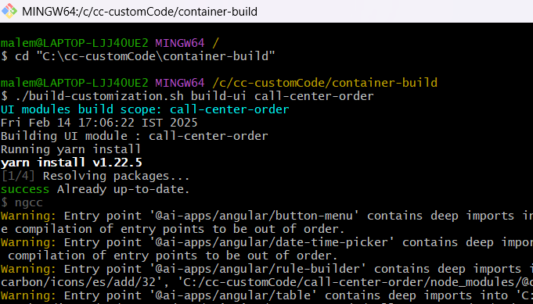

./build-customization.sh build-ui call-center-order

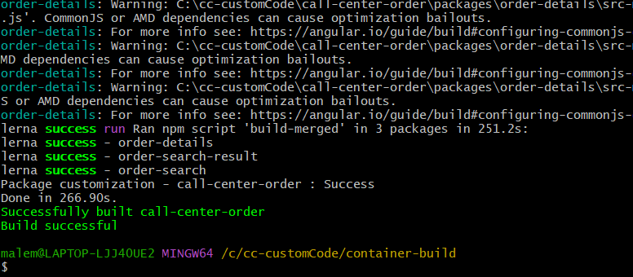

This will create jar

./build-customization.sh package-jar call-center-order

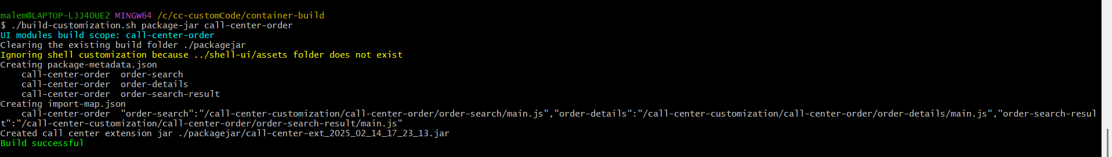

Jar is at following path - C:\cc-customCode\container-build\packagejar

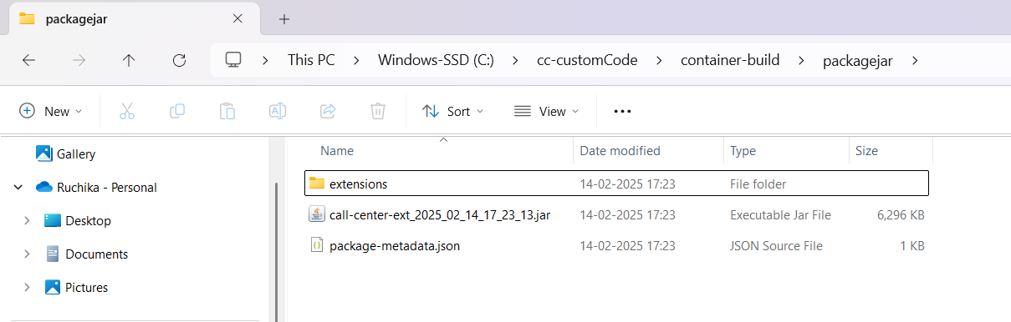

Copy those folders and files from the path that is inside “C:\IBM\oms10FP\repository\callcenter\code\call-center\callcenter_code\container-build\packagejar\extensions” and paste it into the wsl html directory “\var\www\html\ext\call-center”

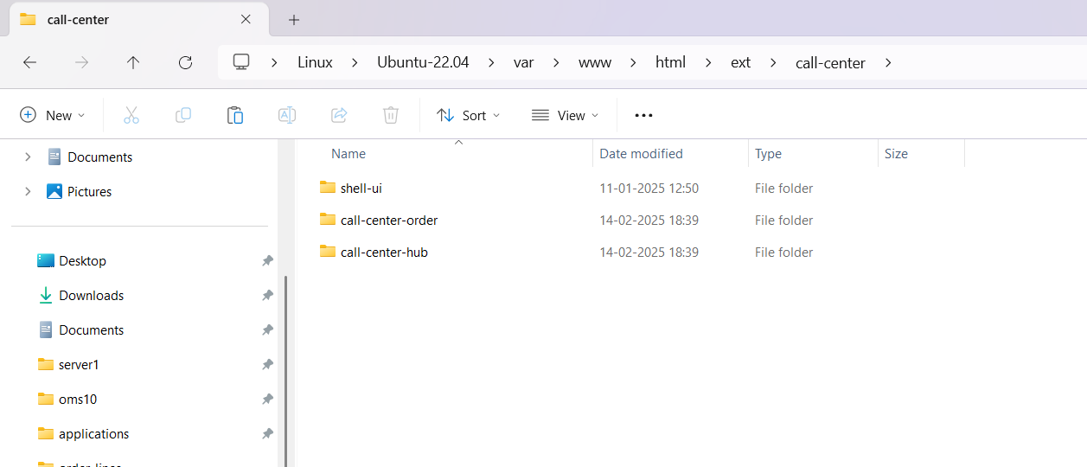

Remove the "**devMode**": true property from the custom app-bootstrap-config.json file if it was added earlier

